**ODM – workflow**

Jenkins build

Build BANCA Service

Build Rule app

Build BANCA POA Service

Build Rule App

Artifacts are stored in **Workspace**

Each service produce two artifacts:

Service.jar

Service Rule App.jar

POA Service.jar

POA Service Rule App.jar

Jenkins(deploy)

Deploy BANCA POA Service

Deploy Rule App

Unit test

Run BANCA POA Test

Execute SOAP Test

Current workflow using TFS**:**

Pull all the codes from the

repository and visual studio will

create workspace in TFS

**Build**

Choose the required Service

**Output**

Jar file created

**deployment**

Select the Jar Major/Minor version

And server details

We have four **environment** as show in the below screenshot

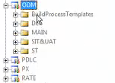

**MAIN – Production branch**

They do not maintain any specific production branch

They will cut it from the development branch once the testing is done till UAT

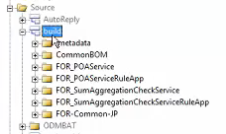

**BANCA- Release**

As a part of Banca project, they have added 4 new service.



Totally, we have 8 services which will share the common component of the below service.

* COMMON-BOM
* FOR-Common-JP

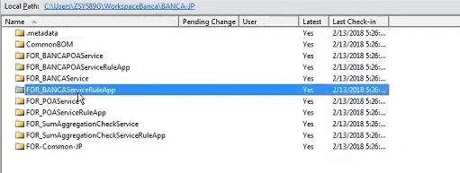

**Migration:**

We need to migrate the below folder to the bitbucket repository as a part of Banca project.

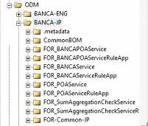

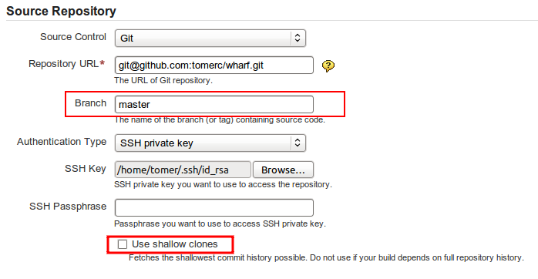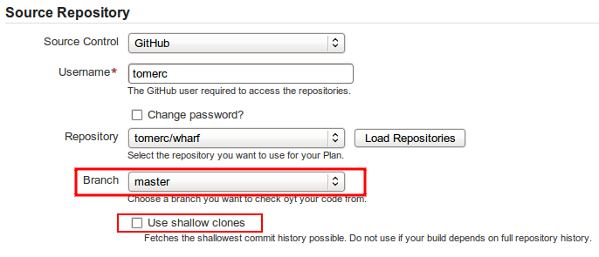

During the release, the plugin performs the following steps:

1. If **Create Branch** is checked, create and switch to the release branch.
2. Commit the release version to the current branch.
3. Create a release tag.
4. Push the changes.
5. Switch to the checkout branch and commit the next development version.
6. Push the next development version to the working branch

**Shallow Clones**

Bamboo's Git plugin allows the use of shallow clones, however this causes the "push" not to work.

Therefore, when using the Artifactory Bamboo Plugin, you must have shallow clones **unchecked**.

For more information about shallow clones, please refer to [git-clone Manual Page](http://www.kernel.org/pub/software/scm/git/docs/git-clone.html).

## **Working with Perforce**

Release management with [Bamboo Artifactory Plugin](https://www.jfrog.com/confluence/pages/viewpage.action?pageId=33357898) supports Perforce when using one checkout directory.

During the release the plugin does the following:

1. Commits the release version directly to the tag (if **Create VCStag** is checked). The release version is not committed to the working branch.
2. Commits the next development version to the working branch

**Changes**

Changes are only committed if the files are modified (POM files or gradle.properties).